# Test 0ne：

User Story:

Try to browser a roots-editing page without login, but redirect to the login page

Description:

After a user’s successful login a identity will be stored in the session. And before a user browser a certain page, that is a filter to check if the user have rule to visit the page.

The authorization is the following code:

|  |
| --- |
| root = Root.authenticate(params[:username], params[:password])  if root  session[:root] = root  session[:identity] = "Root"  redirect_to(:controller=>"admin_root", :action => "index")  else  flash[:notice] = "Invalid user/password combination"  end |

The filter of root is like this in C:\IdeaProjects\iad\app\controllers\application.rb

|  |
| --- |
| def authorize_root  unless session[:identity] == "Root"  flash[:notice] = "Please log in"  redirect_to(:controller => "login", :action => "login")  end  end |

**Test:**

We write following codes in C:\IdeaProjects\iad\test\functional\admin_root_controller_test.rb

|  |
| --- |
| def test_index_without_user  get :index  assert_redirected_to :controller => "login", :action => "login"  assert_equal "Please log in", flash[:notice]  end |

Since we haven’t logged in, a valid root identity isn’t in the session, so the request gets redirected to the login action. According to authorize, the resulting page should include a flash notice telling us that we need to log in. So when we request the index action, we expect to get redirected to the login action and see a flash notice generated by the view.

A screenshot of the result of our test is shown below

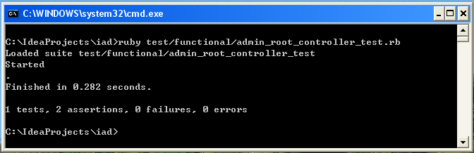

How it start:

Just input the following command at the base path of iAd

*ruby test/functional/admin_root_controller_test.rb*

## Test Two